**The hall of entrepreneurs, patrons and benefactors of the 19th - early 20th century**

1. **Study the information about the Bashkirovs in the showcase, then read and complete the text with the given words and word combinations:**

guild hay and then grain stamp profitable

fleet engines transportation serfs

geographical stock had exceeded

**THE BASHKIROVS**

The Bashkirovs originated from the **1)** ………….. from Nizhnii Novgorod province. The founder of the trading house “Iemelian Bashkirov and Sons” was Iemelian Grigorievich Bashkirov. In the 60s of the 19th century he bought himself and his three sons from serfdom, purchased a shop and a barge in Nizhnii Novgorod and began trading, first in **2)** ……………. To save on **3)** ……………….., Iemelian and his sons pulled barges up the Volga themselves. The business went well, and by 1871 Iemelian Grigorievich, being a merchant of the first **4)** ………….., had founded the trading house. He was illiterate, so all the documents were singed by a competent friend. The Bashkirovs built their first watermills because it was much more **5)** ……………… to trade flour than grain.

Due to advent of steam **6)** ……………. in mills and steamships, the milling business began to develop rapidly. Big flour mills were built. By 1908 the value of Bashkirov enterprises **7)** ……………. 12 million rubles (the initial capital of the trading house was 60 thousand rubles). A cargo **8)** …………… appeared, Bashkirov’s shops and **9)** …………. exchanges were situated not only in Nizhnii Novgorod, but also in Moscow, St. Petersburg, Samara, Astrakhan, Riga. Warehouses were opened in Helsingfors (today’s Helsinki), Hamburg, Lubeck, Berlin.

At the All-Russian Art and Industrial Fair in 1896, where Bashkirov brothers had a pavilion, their main product – grain – received a gold medal. The Bashkirovs were given the right to put a personal **10)** …………. on their bags. At this time, the Volga region became the centre of milling industry, due to its **11)** ……………. location and the development of the railway network.

**Answer the questions:**

1. What was the social origin of the Bashkirovs?
2. What factors influenced the development of the Bashkirovs’ business?
3. What did the membership in the first guild mean for the merchants?

_____________________________________________________________________________________________________________________________________________________________________________________________________________________________________________________________________________________________________________________________

1. **Find the representatives of the Bashkirov family among the portraits:**
2. 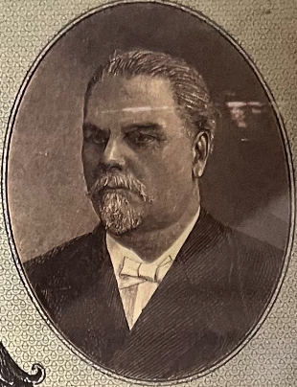 2) 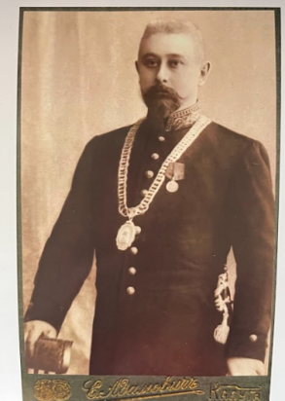 3) 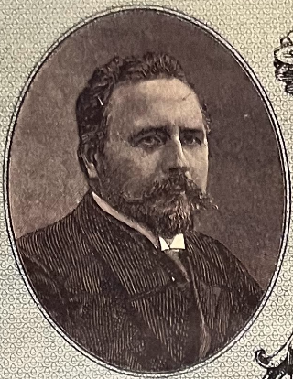

4) 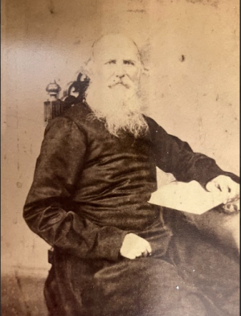 5) 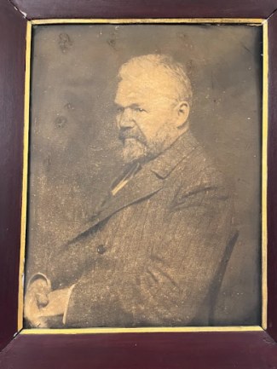 6) 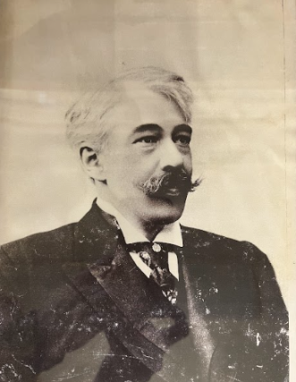

_________________________________________________________

1. **Give a brief presentation of the exhibit (use the information from the text and the showcase):**



